**Deploy Python App**

**Step 1 :create python.yaml**

# vim python.yaml

apiVersion: apps/v1

kind: Deployment

metadata:

name: python-deployment

labels:

app: python

spec:

replicas: 3

selector:

matchLabels:

app: python

template:

metadata:

labels:

app: python

spec:

containers:

- name: python-container

image: gcr.io/vocal-camera-264620/python:v1

ports:

- containerPort: 5000

**Step 1.A : List the replica set**

# kubectl get rs

**Step 2 : create deployment**

# kubectl create -f python.yaml

**Step 2.A : List the replica set**

# kubectl get rs

**Step 3 :List pods**

# kubectl get pods

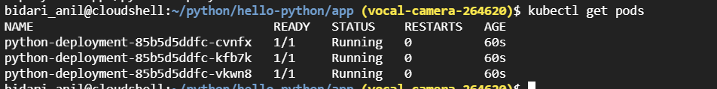

**Step 4 :Get the details about deployment and you can see v1 is deployed**

# kubectl describe deployment python-deployment

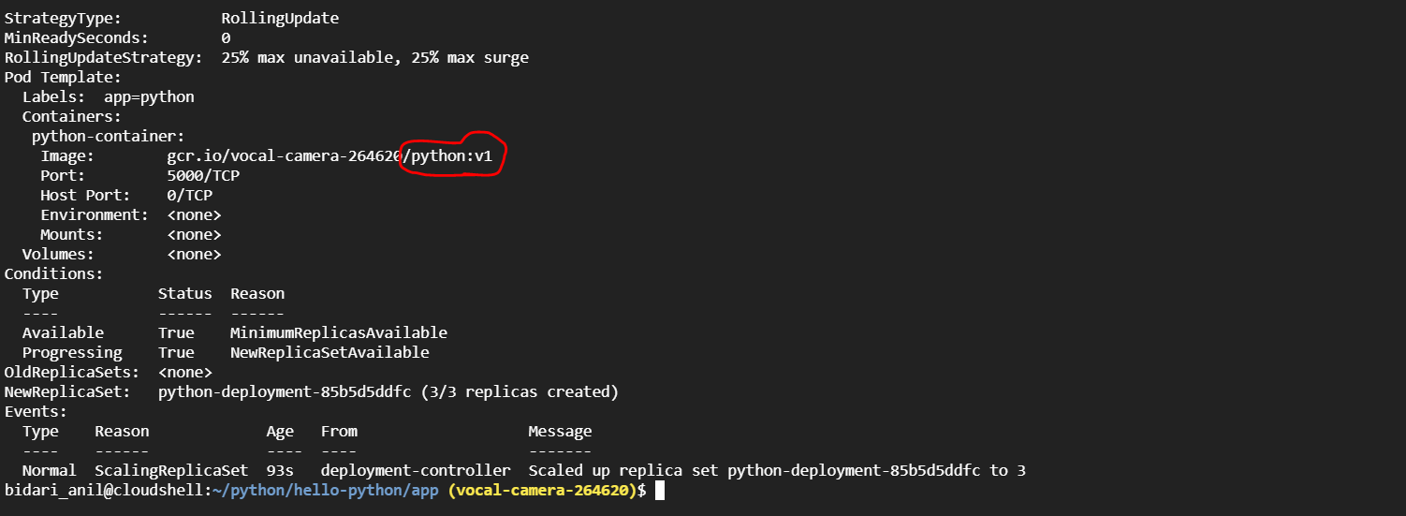

**Step 5 : Describe services**

# kubectl get deployment

